**To use CloudSim in Eclipse:**

1)Download CloudSim 3.0.3.zip file from

<https://github.com/Cloudslab/cloudsim/releases(assets)>

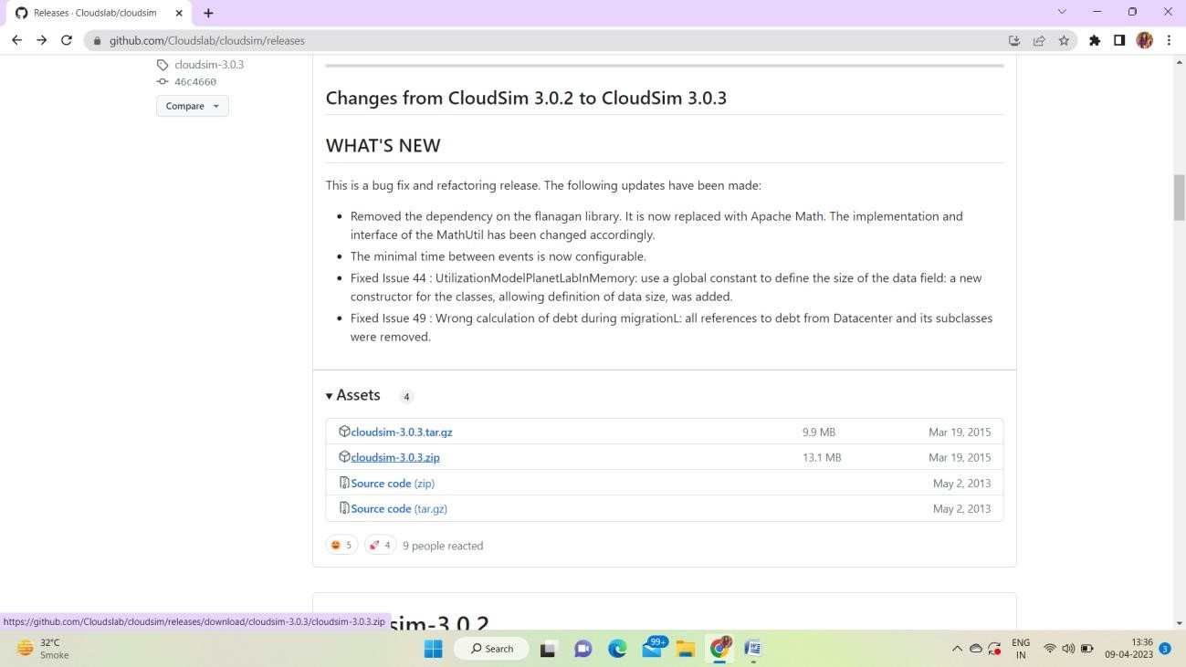

2)Extract the zip file in particular folder.

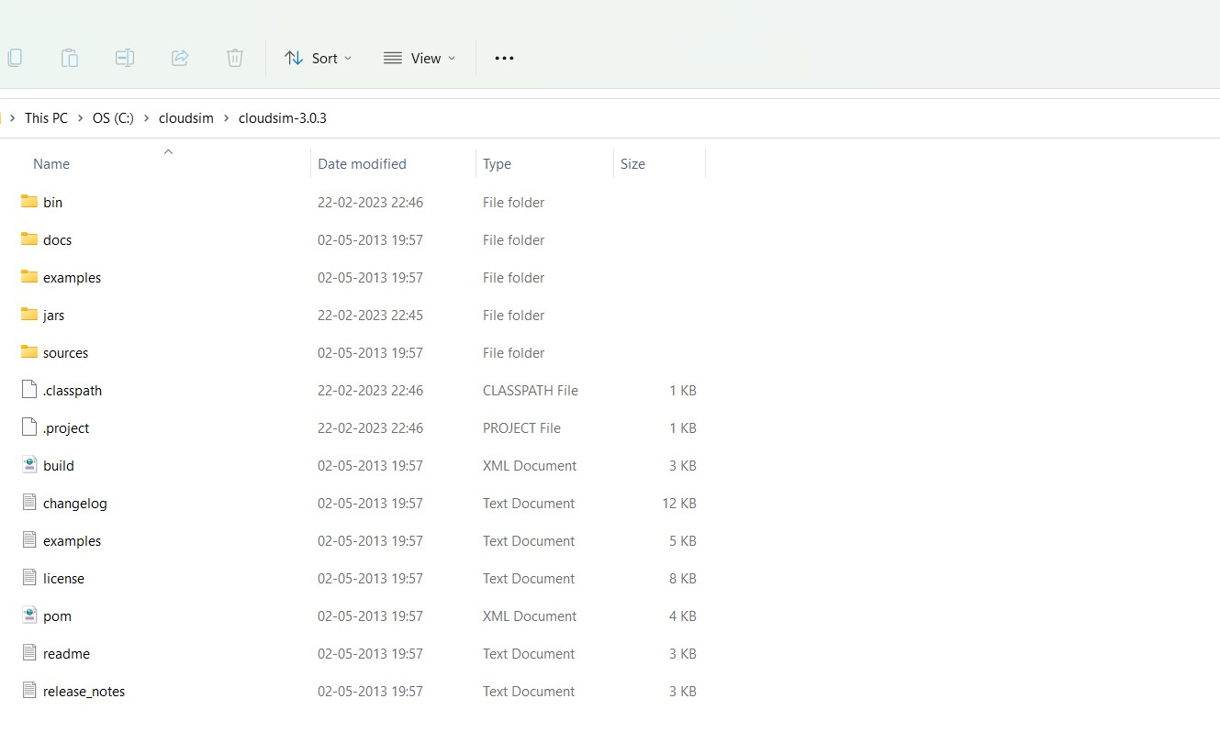

3)Download Common-math jar ([http://www.java2s.com/example/jar/c/downloadcommonsmath3361jar-file.html)](http://www.java2s.com/example/jar/c/download-commonsmath3361jar-file.html)

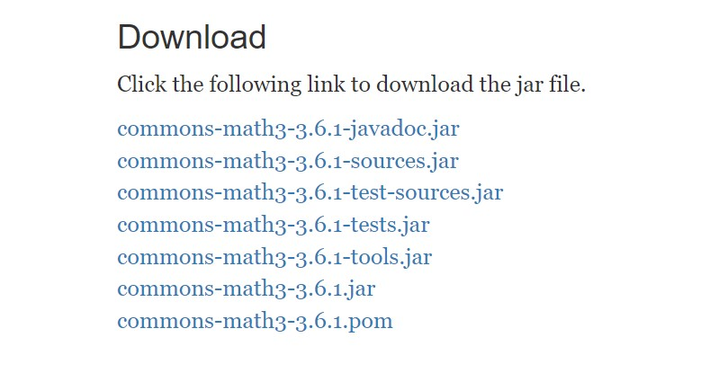

4)Copy common-math.jar file in the same folder created for cloudsim

5)Create a new Java Project: File -> New & Java Project

6)Import an unpacked CloudSim project into the new Java Project

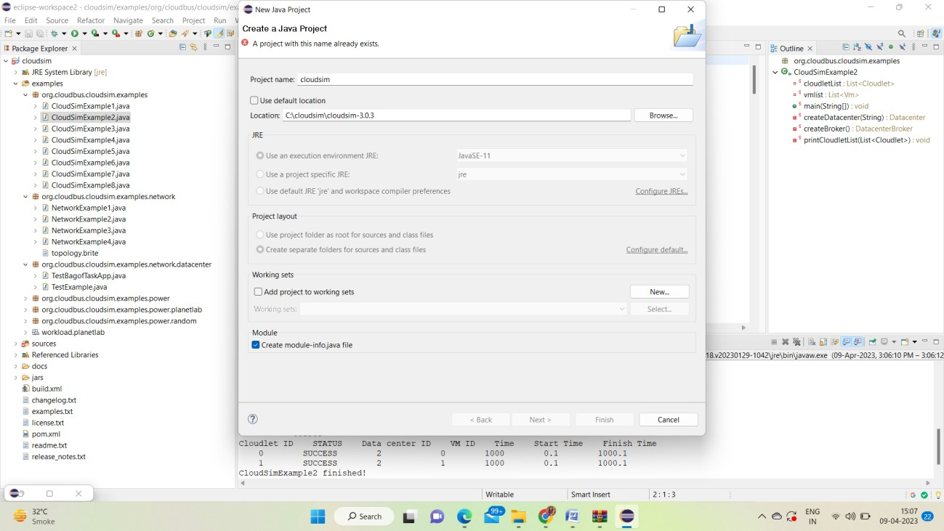

7)Cloudsim scheduling examples (Example1)

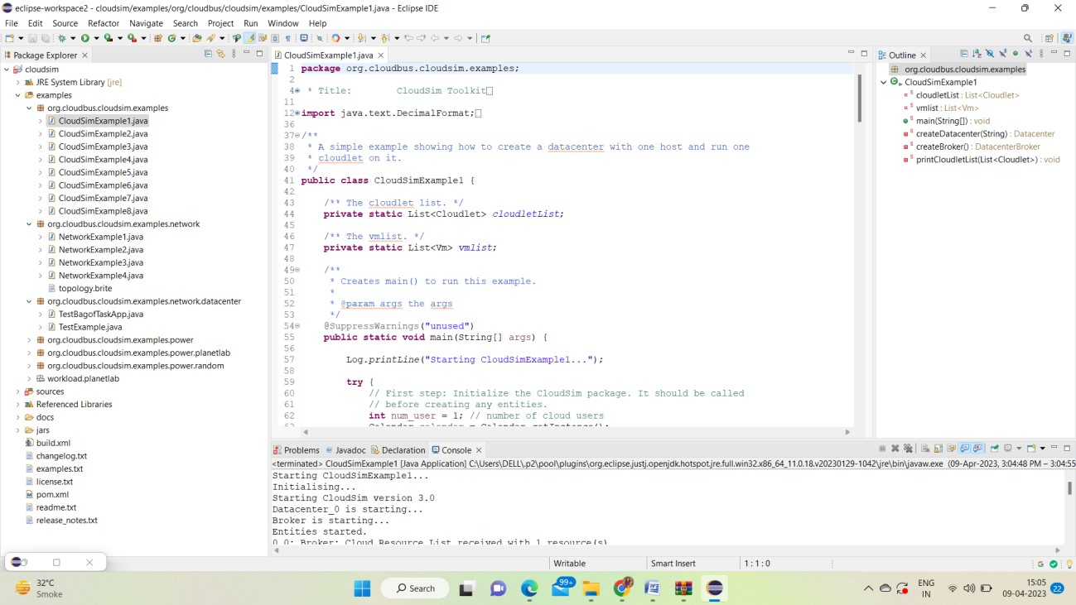

example2:

